First make sure you have the right vehicle(implement)
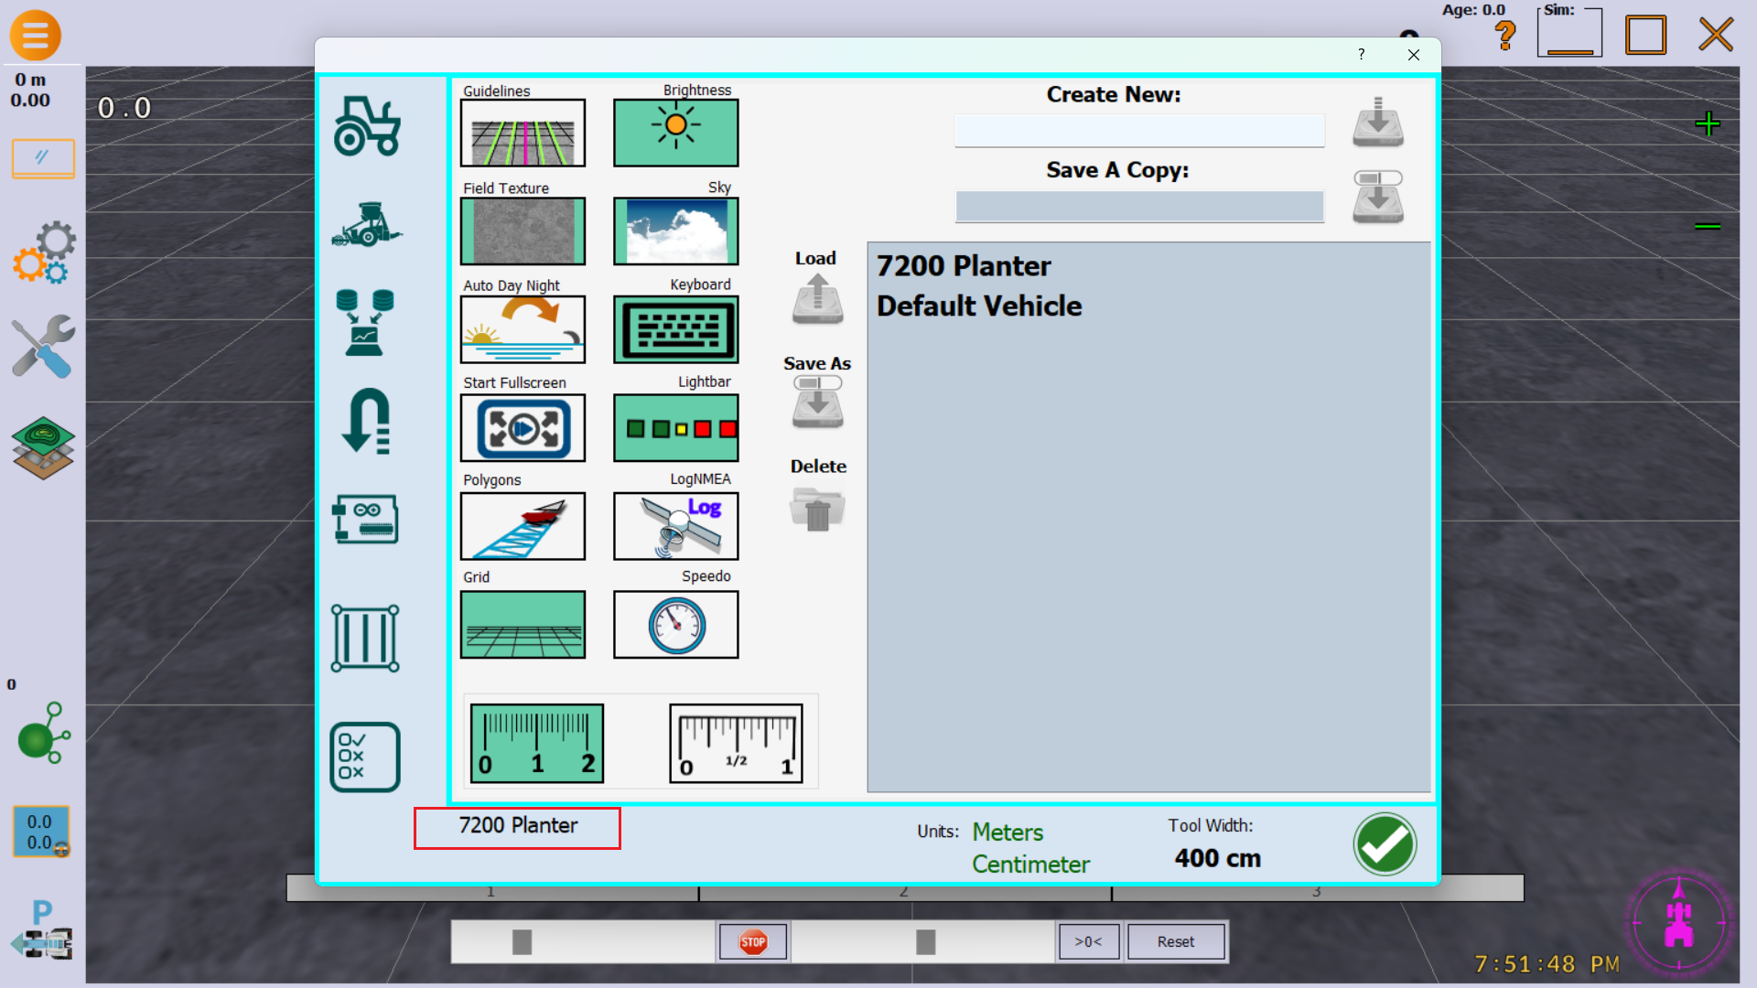
Click
The current vehicle is displayed in the lower left hand corner.

If it is right, click 

If it is not right, go to section on changing the vehicle.

---------------------------------------------------------------------------------------------------------------------------
Next make sure you have the right field.
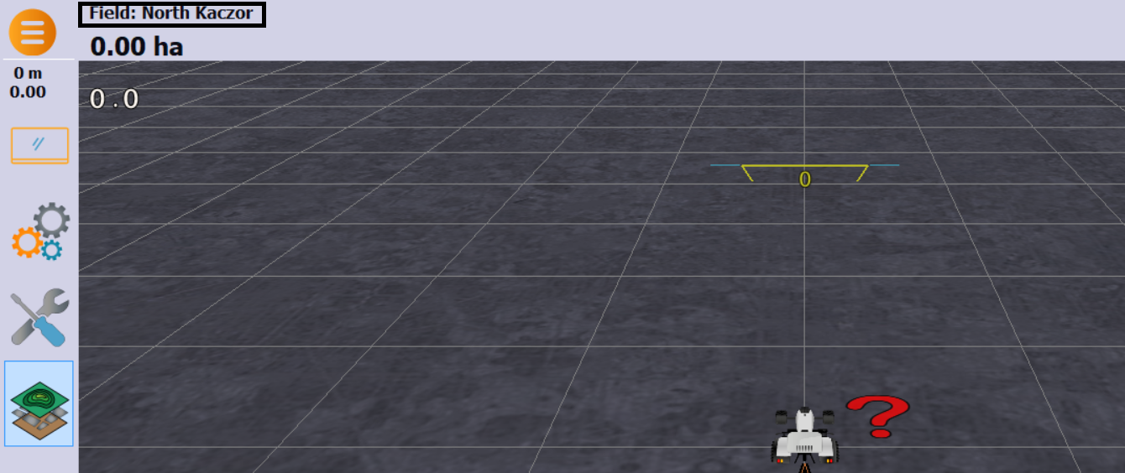
The current field is displayed on the main screen in the top left hand corner.

If its blank, then no field is open and you will have to open one. Go to section on opening a field.

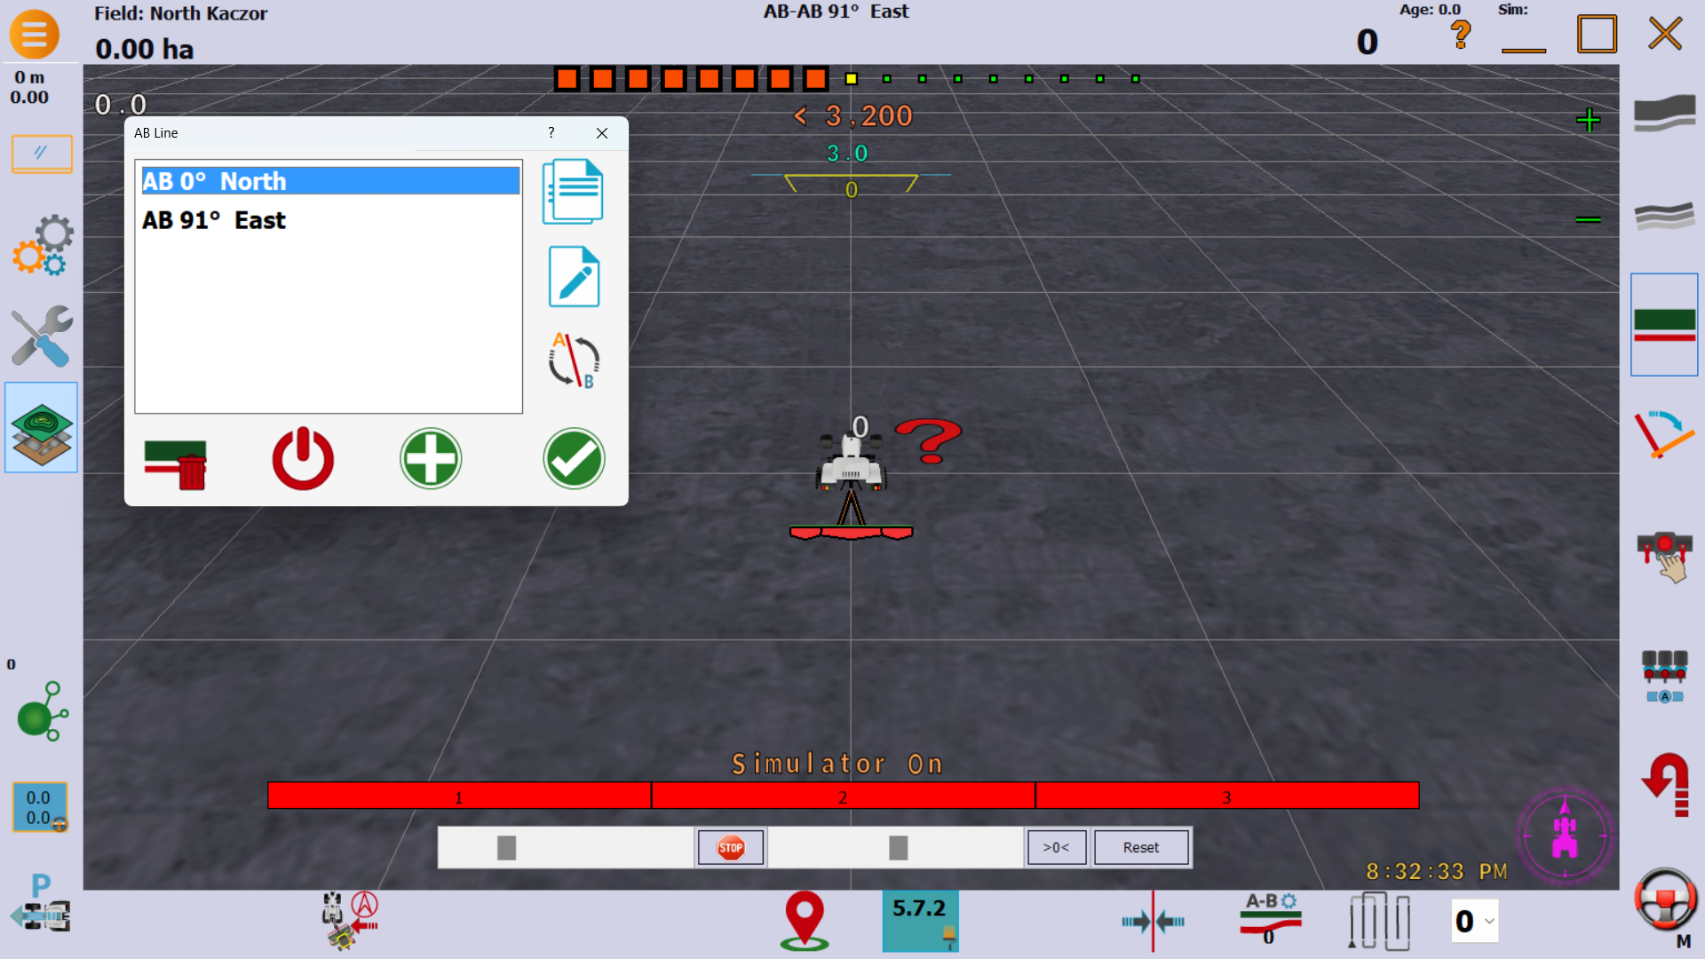
To select an AB Line or AB Curve:
Click  to select AB Line.

 will select AB Curve.

Then select the line or curve you want by clicking it:
Then click The process is the same for AB Line or AB Curve.

Sometimes the GPS system thinks it’s going in reverse when its not. It shows when its in reverse with a big red arrow. Click on the tractor in the middle of the screen when this happens then drive forward faster than one mile per hour to reset the direction.

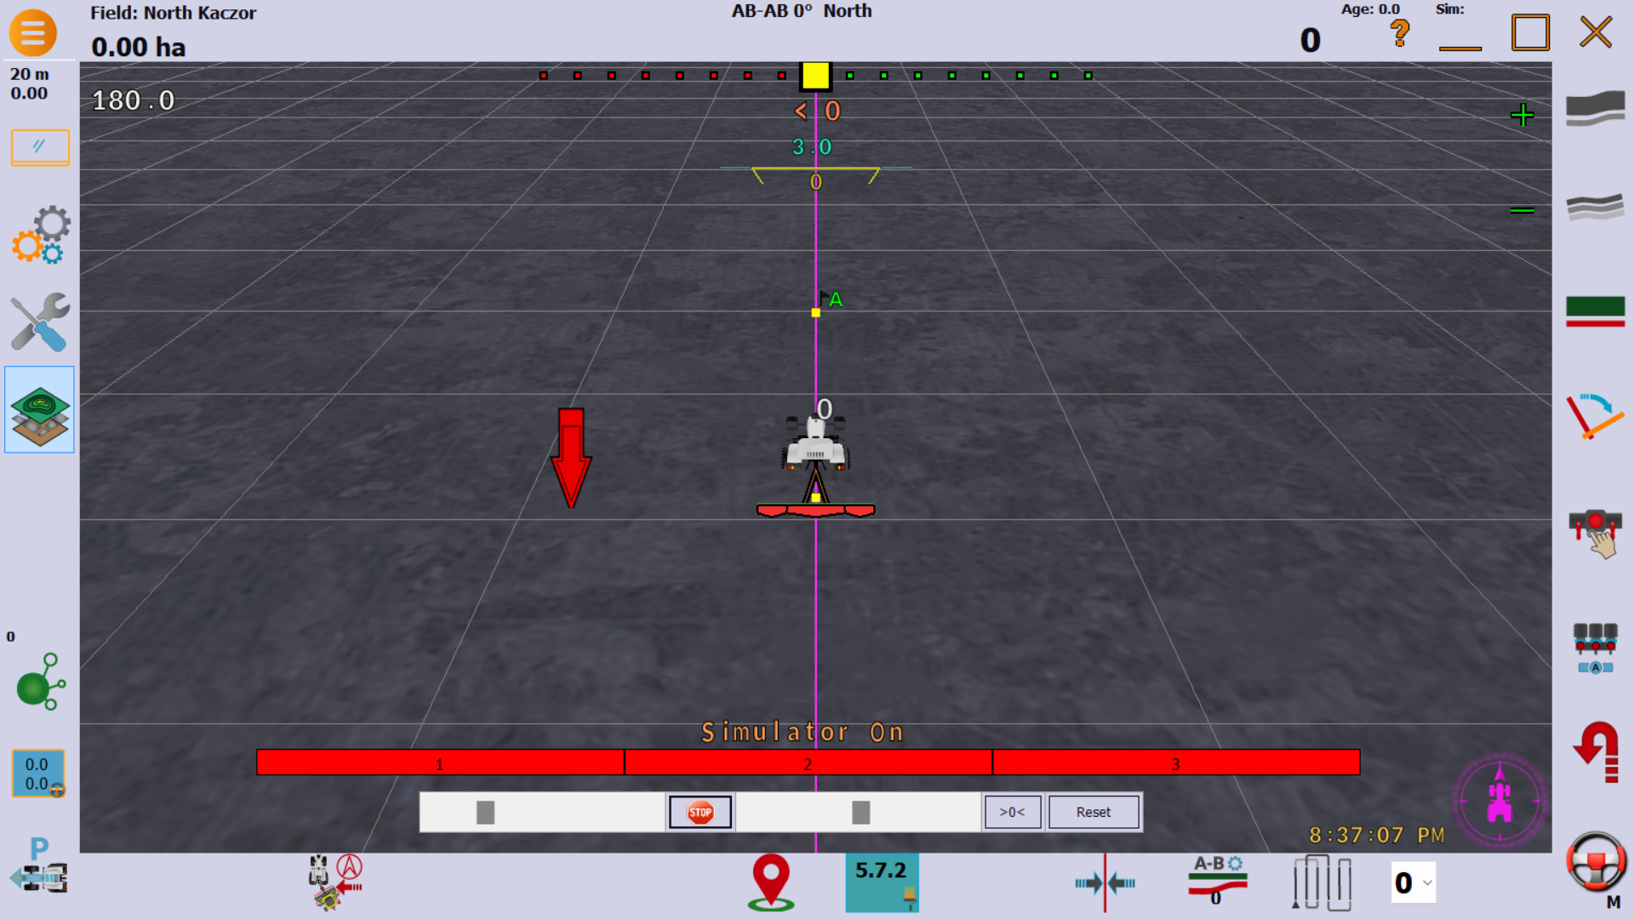
-------------------------------------------------------------------------------------------------------------------------
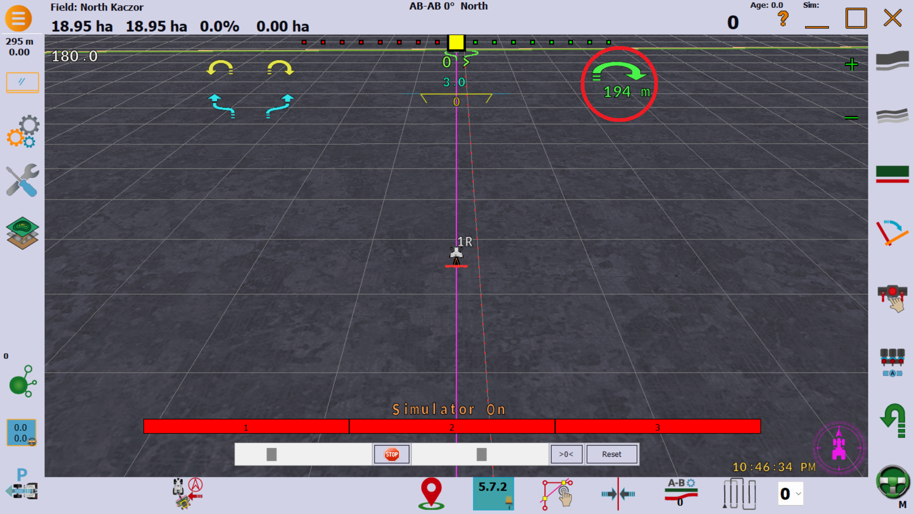
To start auto u-turn, click the  button WITH THE AUTOSTEER ENGAGED. The green u turn symbol should appear, with the countdown to the turn. Click it to change which direction it turns.

I have it set to skip a pass every time. It seems to work better, and is easier on the steering.
-----------------To change the vehicle:----------------------
Click then select the vehicle you want by clicking on it in the box. Then click the “Load” button. If it pops up a box that says “Field is open, close field first” then close the field, and come back.
Then click “Yes” on the box that pops up. Then click
-----------------To change the field:----------------------
To change the field, you must first close the old field(go to section on closing field and come back.)
Then you must open the new field(go to section on opening fields.
----------------- To close the field:---------------------
Click on  Then click “Field”. Then Click “Close”
-----------------To open the field:-----------------
Click on Then click “Open”. Then select the field you want by clicking on it.
Then click “Use Selected”.
-----------------To start Section Control(Mapping)
Click to turn on. Click it again to turn off.
------------------To clear old mapping(coverage)
AgOpenGPS has a builtin acre counter, therefore it makes sense to clear out the old mapping data every time you start a new field.
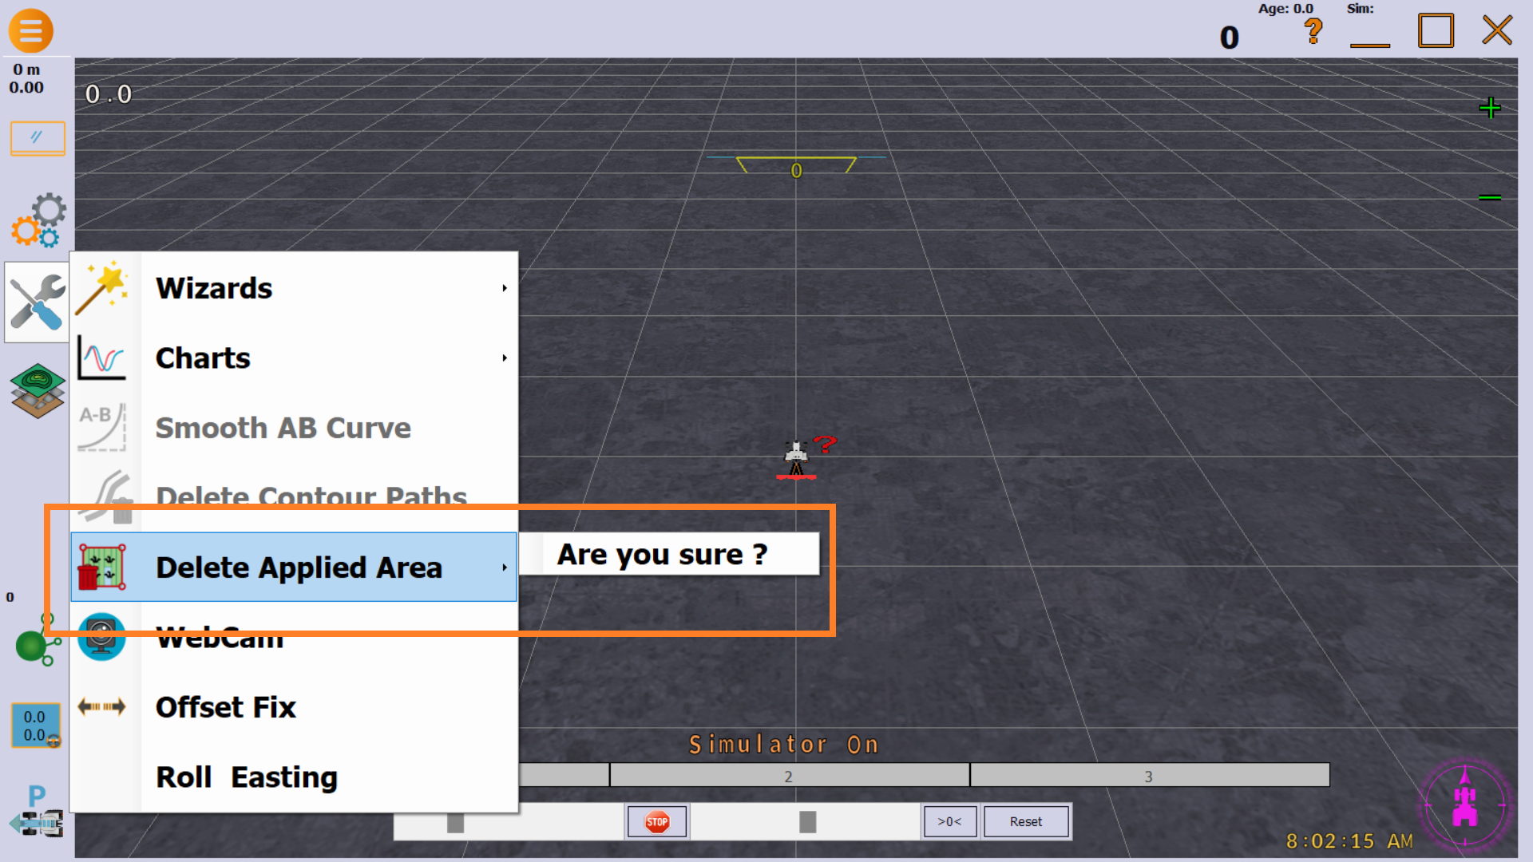
Click on the main screen.
Then click “Delete Applied Area”
Then click “Are you sure?”.
then click “Yes” on the box that pops up.

In a few situations, it might be necessary to move the AB Line. This should never need to
happen, though. But to move AB Line, click the button. It centers the AB Line on the vehicle like the old one did.

---------------Using the Acre Counter
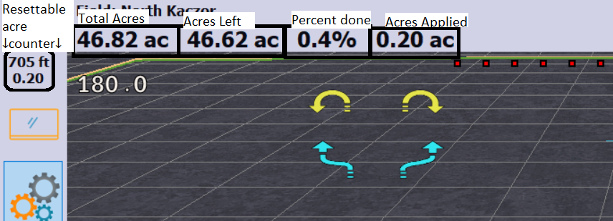
The resettable acre counter (the bottom number is the acres) can be reset by clicking it anytime. this can be used when refilling the planter to see how far the full planter can go with the current setting. Resetting this will not clear out the Applied acres on the main screen.

